Eksamen august 2016
Exercise 1
Q1
Form properties of the forwardrates we simply calculate
1.
$$P_{1}=\frac{1}{1,05}≈0,952$$
2.
$$P_{2}=\frac{1}{1.05·1.04}≈0,916$$
3.
$$P_{3}=\frac{1}{1.05·1.04·1.06}≈0,864$$
We write this as a vector
$$d=\left(\begin{aligned}0.952 \\ 0.916 \\ 0.864\end{aligned}\right)$$
Q2 ill assume a facevalue of 100
$$B=\left(\begin{matrix}3 & 3 & 103\end{matrix}\right)$$
$$P=B·d=\left(\begin{matrix}3 & 3 & 103\end{matrix}\right)\left(\begin{aligned}0.952 \\ 0.916 \\ 0.864\end{aligned}\right)=94,596$$
Q3 same as before
This one is a little more tricky
With cuponrate a
$$B_{a}=\left(\begin{matrix}\frac{100}{3}+100·a & \frac{100}{3}+\frac{100}{2}·a & \frac{100}{3}+\frac{100}{3}·a\end{matrix}\right)$$
$$\left(\begin{matrix}\frac{100}{3}+100·a & \frac{100}{3}+\frac{2·100}{3}·a & \frac{100}{3}+\frac{100}{3}·a\end{matrix}\right)\left(\begin{aligned}0.9524 \\ 0.9158 \\ 0.8639\end{aligned}\right)=185,09·a+91,07$$
$$185,09·a+91,07=99$$
$⇕$ Ligningen løses for a vha. WordMat.
$$a=0,043$$
Q4
For annuities the market is incomplete because they arent linearly inependent
If 1 is a serial with cupon different from 0 then the market will be complete since the 2 introduced bonds will be inearly independent

$$B_{4}=\left(\begin{matrix}20+5 & 20+4 & 20+3 & 20+2 & 20+1\end{matrix}\right)$$

$$((((100·1.03-x)·1.03-x)·1.03-x)·1.03-x)·1.03-x=0$$
$⇕$ Ligningen løses for x vha. WordMat.
$$x=21,835$$
$$B_{5}=\left(\begin{matrix}21,835 & 21,835 & 21,835 & 21,835 & 21,835\end{matrix}\right)$$
$$B=\left(\begin{matrix}1 & 0 & 0 & 0 & 0 \\ 0 & 1 & 0 & 0 & 0 \\ 0 & 0 & 1 & 0 & 0 \\ 25 & 24 & 23 & 22 & 21 \\ 21,835 & 21,835 & 21,835 & 21,835 & 21,835\end{matrix}\right)$$
$$P=\left(\begin{aligned}0.952 \\ 0.916 \\ 0.864 \\ 100.94 \\ 95.47\end{aligned}\right)$$
$${\left(\begin{matrix}1 & 0 & 0 & 0 & 0 \\ 0 & 1 & 0 & 0 & 0 \\ 0 & 0 & 1 & 0 & 0 \\ 25 & 24 & 23 & 22 & 21 \\ 21,835 & 21,835 & 21,835 & 21,835 & 21,835\end{matrix}\right)}^{-1}\left(\begin{aligned}0.952 \\ 0.916 \\ 0.864 \\ 100.94 \\ 95.47\end{aligned}\right)≈\left(\begin{matrix}0,952 \\ 0,916 \\ 0,864 \\ 0,837 \\ 0,803\end{matrix}\right)=d>0$$
Exercise 2
$$D=\left(\begin{matrix}80 & 90 & 35 \\ 90 & 64 & 55 \\ 25 & 35 & 96\end{matrix}\right)$$
$${\left(\begin{matrix}80 & 90 & 35 \\ 90 & 64 & 55 \\ 25 & 35 & 96\end{matrix}\right)}^{-1}=\left(\begin{matrix}-\left(\frac{4219}{262080}\right) & \frac{1483}{52416} & -\left(\frac{271}{26208}\right) \\ \frac{1453}{52416} & -\left(\frac{1361}{52416}\right) & \frac{125}{26208} \\ -\left(\frac{155}{26208}\right) & \frac{55}{26208} & \frac{149}{13104}\end{matrix}\right)≈\left(\begin{matrix}-0,016 & 0,028 & -0,01 \\ 0,028 & -0,026 & 0,005 \\ -0,006 & 0,002 & 0,011\end{matrix}\right)$$

$$P=\left(\begin{aligned}54.25 \\ 58.75 \\ 56.95\end{aligned}\right)$$
$${\left(\begin{matrix}80 & 90 & 35 \\ 90 & 64 & 55 \\ 25 & 35 & 96\end{matrix}\right)}^{-1}\left(\begin{aligned}54.25 \\ 58.75 \\ 56.95\end{aligned}\right)≈\left(\begin{matrix}0,2 \\ 0,25 \\ 0,45\end{matrix}\right)=ψ>0$$
Then the market is arbitrage free
Since D is invertible and $D^{-1}P=ψ>0$ then the market is arbitragefree and complete and thus any asset can be replicated as a combination of these 3 assets
$$ψ_{0}=0.2+0.25+0.45=0,9=d_{1}$$
$$r_{f}=\frac{1}{d_{1}}-1=\frac{1}{0.9}-1=\frac{1}{9}$$
Q4 im assuming we need to find the expectation under the physical measure
$$E^{P}\left[S_{1}\right]=\frac{1}{4}·80+\frac{1}{2}·90+\frac{1}{4}·35=\frac{295}{4}=73,75$$
$${\overline{r}}_{1}=\frac{73,75-54.25}{54.25}≈0,359$$
$$E^{P}\left[S_{2}\right]=\frac{1}{4}·90+\frac{1}{2}·64+\frac{1}{4}·55=\frac{273}{4}=68,25$$
$${\overline{r}}_{2}=\frac{68,25-58.75}{58.75}≈0,162$$
$$E^{P}\left[S_{3}\right]=\frac{1}{4}·25+\frac{1}{2}·35+\frac{1}{4}·96=\frac{191}{4}=47,75$$
$${\overline{r}}_{3}=\frac{47,75-56.95}{56.95}≈-0,162$$
The expected return of asset 3 is negative which makes it unattractive but at the same time it is the only asset with a positive return in state 3 which makes it attractive as part of a portfolio with asset 1 which only major drawdown is the low return in state 3

Q5
Since known risk free rate
$$G_{0,1}=\frac{S_{0}}{d_{0,1}}=\frac{54.25}{0.9}≈60,278$$

Q6
Payoff:
$$D_{4}=\left(\begin{matrix}0 & 5 & 66\end{matrix}\right)$$
We price with stateprices
$$P=D_{4}·ψ=\left(\begin{matrix}0 & 5 & 66\end{matrix}\right)·\left(\begin{matrix}0,2 \\ 0,25 \\ 0,45\end{matrix}\right)=30,95$$

Replicating portfolio
$$\left(\begin{matrix}0 & 5 & 66\end{matrix}\right){\left(\begin{matrix}80 & 90 & 35 \\ 90 & 64 & 55 \\ 25 & 35 & 96\end{matrix}\right)}^{-1}=\left(\begin{matrix}-\left(\frac{145}{576}\right) & \frac{5}{576} & \frac{223}{288}\end{matrix}\right)≈\left(\begin{matrix}-0,252 & 0,009 & 0,774\end{matrix}\right)$$
Exercise 3
Q1
We see thatwe have constant up and downs
$$u=1.05$$
$$d=0.95$$
Thus we only need
$$e^{r_{f}}∈\left(0.95, 1,05\right)$$
$$\ln\left(0.95\right)≈-0,051$$
$$\ln\left(1.05\right)≈0,049$$
$$r_{f}∈(-0.051, 0.049)$$
Yes it is consistent with no arbitrage if rates are negative
When considering arbitrage(when considering the risk free rate) we should think about if there is either a way to borrow and invest for a GARUENTIED profit
Or sell the asset short and invest at the risk free rate
As long as the asset dosent either
Always have higher return than then risk free asset
Or always has lower return than the risk free asset
Then we are consisten with no arbitrage
Which is exactly the bounds written above(with some precision error)
Q2
$$q=\frac{e^{0.02}-0.95}{1.05-0.95}≈0,702$$
$$1-q=\frac{1.05-e^{0.02}}{1.05-0.95}≈0,298$$
Q3
The only state paying out is “up up”
$$c_{0}=e^{-r·T}q^{2}·c_{uu}$$
$$=e^{-0.02·2}·{0,702}^{2}·25.625≈12,133$$
Q4
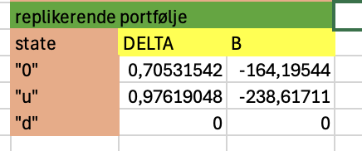
Replicating portfolio in the 3 states
Q5
Im thinking there are 2 obvious ways to show this: put call parity or replication
Im gonna do the put call parity
Assuming that the call is priced at $12.133$
Put call parity states that since long call and short put at same strike has same payoff as a forward
$$C-P=S_{0}-X·d$$
$$⇒P=C-S+X·d$$
$$P=12.133-250+250·e^{-0.02·2}≈2,33>2.25$$
Thus by selling the replication and buying the put we get 0.08 today with no payoffs in the future creating an arbitrage

In detail we buy the put in the market sell the Call at the same strike and maturity buy 1 stock and borrow the discounted value of the strike

Q6 again we use the put call parity
$$C-P=S-X·d$$
Differantiate both sides with respect to the stockprice
$$\frac{∂C}{∂S}-\frac{∂P}{∂S}=1$$
We do it again
$$\frac{∂^{2}C}{∂S^{2}}-\frac{∂^{2}P}{∂S^{2}}=0⇔\frac{∂^{2}C}{∂S^{2}}=\frac{∂^{2}P}{∂S^{2}}$$
$$⇒Γ_{call}=Γ_{put}$$

Exercise 4
Q1
Since they are uncorrelated their covariance is 0
$$Var\left(α·A+\left(1-α\right)B\right)=a^{2}·σ_{A}^{2}+{\left(1-α\right)}^{2}σ_{B}^{2}$$
The covariance is 0
$$σ_{p}^{2}=a^{2}·σ_{A}^{2}+{\left(1-α\right)}^{}σ_{B}^{2}=a^{2}·0.16+{\left(1-α\right)}^{2}0.09=0,09-2α·0.09+0.25·α^{2}$$
$$μ_{p}=α·μ_{A}+\left(1-α\right)μ_{B}=α·0.1+\left(1-α\right)0.2=0,2-0,1·α$$
Q2
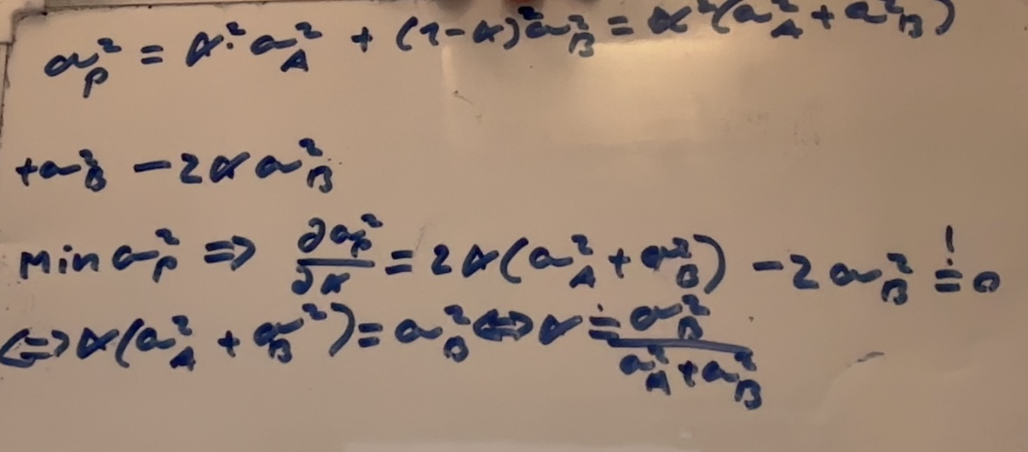
We simply have a unconstrained maximization problem
Q3
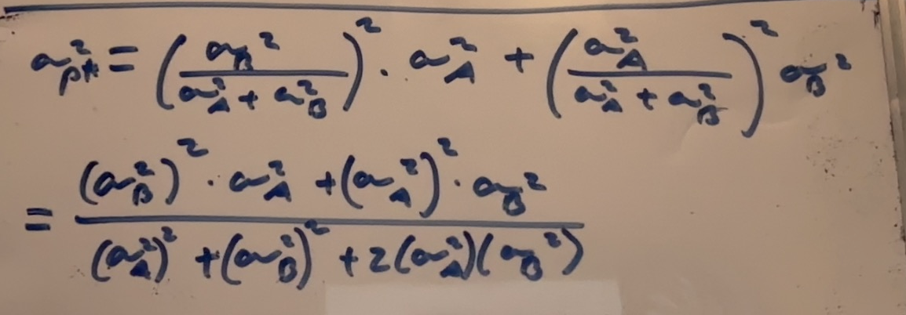
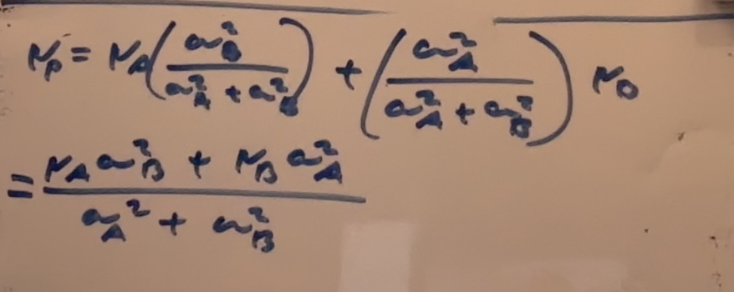

For the data given
$$σ_{P}^{2}={\left(\frac{0.09}{0.09+0.16}\right)}^{2}·0.16+{\left(\frac{0.16}{0.09+0.16}\right)}^{2}·0.09≈0,058$$
$$μ_{P}=0.1·\frac{0.09}{0.09+0.16}+0.2·\frac{0.16}{0.09+0.16}=0,164$$
Q4
In capm we simply asseume that any expected return is bound to an assets covaraince with the market
The situation is simply one where the asset has high enough unsystematic risk such that
$$σ_{A}^{2}=β_{A}^{2}·σ_{m}^{2}+σ_{ϵ_{A}}^{2}>σ_{B}^{2}=β_{B}^{2}·σ_{m}^{2}+σ_{ϵ_{B}}^{2}$$
Even though
$${\overline{r}}_{A}=r_{f}+β_{A}\left(\overline{r_{m}}-r_{f}\right)<{\overline{r}}_{B}=r_{f}+β_{B}\left(\overline{r_{m}}-r_{f}\right)⇒β_{B}>β_{A}$$
Its simply a situation in capm with high(er) systematic risk
Q5
When capm is satisfied the tangentportfolio is the marketportfolio
We use our usual formulas
$$w_{tan}=\frac{Σ^{-1}{\overline{r}}^{e}}{I^{T}·Σ^{-1}{\overline{r}}^{e}}$$
$$Σ=\left(\begin{matrix}0.16 & 0 \\ 0 & 0.09\end{matrix}\right)$$
$${\overline{r}}^{e}=\left(\begin{aligned}0.1 \\ 0.2\end{aligned}\right)-\left(\begin{aligned}0.05 \\ 0.05\end{aligned}\right)≈\left(\begin{matrix}0,05 \\ 0,15\end{matrix}\right)$$
$$w_{tan}=\frac{{\left(\begin{matrix}0.16 & 0 \\ 0 & 0.09\end{matrix}\right)}^{-1}\left(\begin{matrix}0,05 \\ 0,15\end{matrix}\right)}{\left(\begin{matrix}1 & 1\end{matrix}\right){\left(\begin{matrix}0.16 & 0 \\ 0 & 0.09\end{matrix}\right)}^{-1}\left(\begin{matrix}0,05 \\ 0,15\end{matrix}\right)}≈\left(\begin{matrix}0,158 \\ 0,842\end{matrix}\right)$$
Q6 calculate the betas of the stocks
$$σ_{m}^{2}=transpose\left(\left(\begin{matrix}0,158 \\ 0,842\end{matrix}\right)\right)·\left(\begin{matrix}0.16 & 0 \\ 0 & 0.09\end{matrix}\right)\left(\begin{matrix}0,158 \\ 0,842\end{matrix}\right)≈0,068$$
Beta vector
$$β=\frac{1}{σ_{m}^{2}}Σ·w_{m}=\frac{1}{0,068}·\left(\begin{matrix}0.16 & 0 \\ 0 & 0.09\end{matrix}\right)\left(\begin{matrix}0,158 \\ 0,842\end{matrix}\right)≈\left(\begin{matrix}0,372 \\ 1,114\end{matrix}\right)$$
$$β_{A}=0.372$$
$$β_{B}=1.114$$

